Weathermapy Assignment

**Weather Analysis**

Of the 1500 cities randomly selected we use weather API to pull data for those random cities

Below is what the graphs tell us the stories of the cities

1. Temperatures are comparatively higher near 0 to 25 and lower beyond that. The 0 to 25 range is the equator region.
2. 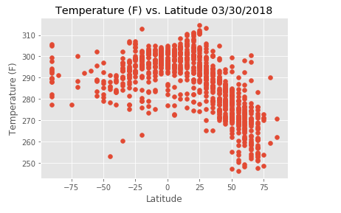
3. Humidity is high near the equator also
4. 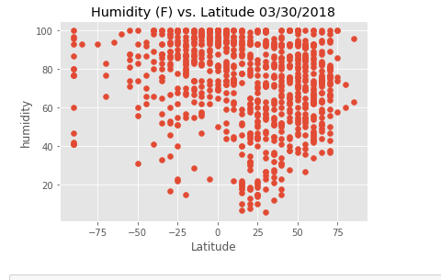
5. Cloudiness is scattered all around almost evenly but more near the equator and in the northern hemisphere.
6. 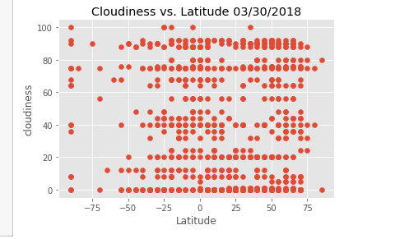
7. Windspeeds are higher near the equator and in the northern hemisphere.
8. 